- Bluebook Page133 May 2019 variant four examination:

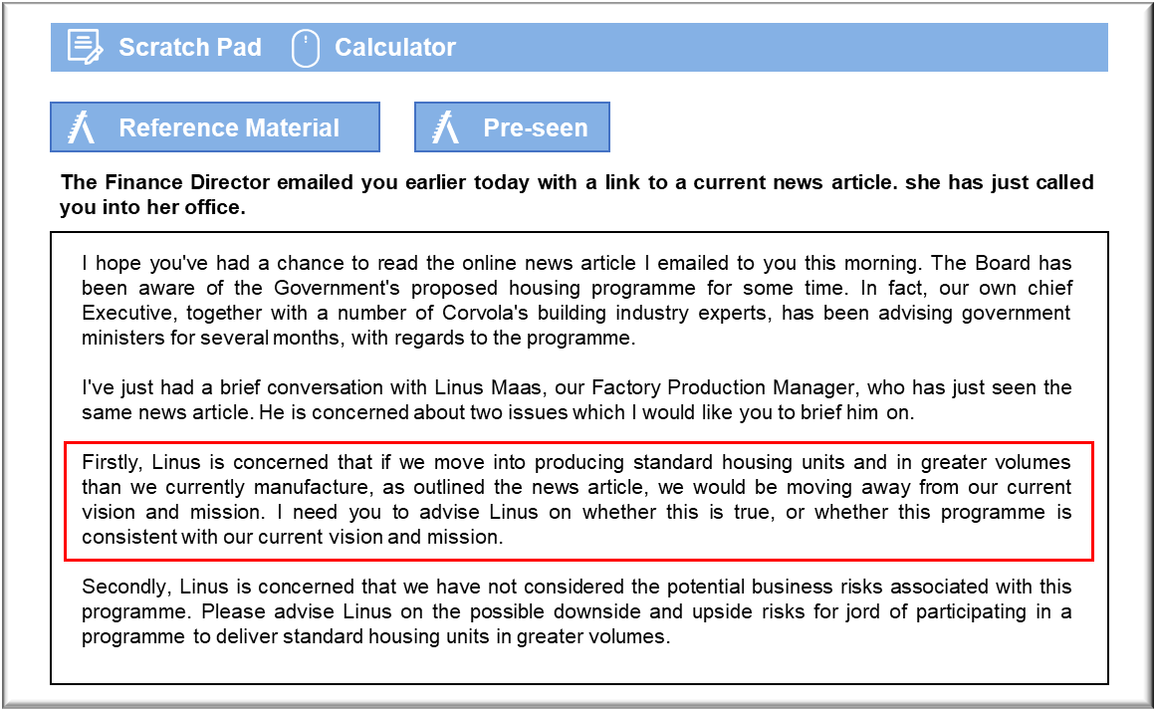

MANAGEMENT CASE STUDY MAY 2019 EXAM ANSWERS

Variant4 Task1
These answers have been provided by CIMA for information purposes only. The answers created are indicative of a response that could be given by a good candidate. They are not to be considered exhaustive, and other appropriate relevant responses would receive credit.

CIMA will not accept challenges to these answers on the basis of academic judgement.

Consistency with our current vision and mission
Linus is partly right to be concerned about whether we will remain true to our vision in
that the houses build for the Corvolan government’s programme will be standard in
design, rather than state of the art. Also, whilst we will need to strive to achieve a high
quality, we may not be able to achieve the levels of quality we do with our existing
houses, due to the need to achieve a lower price and the greater volumes we will be
expected to produce.
The government’s proposal to build standard designed prefabricated houses to help to
solve Corvola’s housing problems is an interesting one. The main issues which may
cause us some concern in relation to this proposals’ suitability are the requirement to
build ‘standard’ designed houses, in much greater volumes, rather than our small
volumes of bespoke designs, and the level of quality expected of the builds.
Our vision is ‘to be acknowledged as the industry leader in the design and construction
of state-of-the-art prefabricated buildings which are of the highest quality, cost
effective and environmentally sustainable’. There is seemingly no reason why this
vision needs to be compromised through our involvement in this proposal. This may be
an opportunity for us to use our expertise and industry experience in state-of-the-art
design, to develop standard designed houses which still meet our levels of quality and
sustainability expectations, even if in greater volumes. These are clearly important
criteria of the programme, as the news blog clearly indicates the governments drive for
increasing sustainability of its housing stock. We are industry leaders in this and
therefore it could be an opportunity to use this expertise in this way. Our cost-effective
focus will also likely be consistent with the outcomes of the proposal, as customers will
be looking for homes which are cost effective and efficient.
However, there may be more concern in terms of the proposal’s suitability with our
mission statement, particularly in relation to our customers. Our current customers
invest in a Jord home for several reasons: its high quality, its environmental
These answers have been provided by CIMA for information purposes only. The answers
created are indicative of a response that could be given by a good candidate. They are
not to be considered exhaustive, and other appropriate relevant responses would
receive credit.
CIMA will not accept challenges to these answers on the basis of academic judgement.
sustainability and for many, the fact that it is a truly unique product. If Jord is to
become involved in this programme, this may be a threat to our claim to offering
unique homes and this may de-value our competitive advantage. This is something we
need to seriously consider as we do not want to lose our existing customer base.
However, we could look at it that in fact the customer in this contract will be the
contractor rather than the individual homeowner.
As for the element of our mission relating to our people, this shouldn’t be affected by
this potential contract. In fact, part relating to secure employment and career
progression is actually enhanced due to the extra work that the contract will bring.
Our mission in terms of the communities we serve will most certainly be enhanced by
taking part in this programme, as we will be actively contributing to the communities
in which we operate by helping to provide an environmentally and sustainable living
environment for our community.
Upside and downside risks of participating in the Government’s housing
programme
There are of course, several risks we must consider before involving ourselves in this
housing programme. Firstly, there is a product reputation risk to consider.
Involvement in this programme may impact on our reputation in the industry as a
provider of high-quality bespoke homes. Our current customers value the fact that we
offer bespoke designs and there is a certain degree of ‘kudos’ in owning a Jord home.
This may be adversely affected if we decide to manufacture large numbers of standard
designed homes.
However, there could also be a potential upside risk to this, as our product reputation
may in fact be enhanced by our involvement in the programme. If we continue to
ensure that we produce high-quality, albeit standard designed houses, this opens up
our availability to a much wider market and our brand will in fact be much wider?known. Our expertise in prefabricated design could be exploited in a much larger
marketplace, thus making the Jord product more prominent in the industry.
There is also a downside product risk in that we may not deliver what is expected or
needed by the end customer or the Government. Mass produced, standard housing is a
completely new concept in Corvola, where large housing estates are not normal
practice. It may be that, although the government is keen to solve the housing shortage
with such housing developments, the end customers themselves may not be interested
in buying standard designed houses on housing developments. This in turn may
impact on the reputation of our product, if our houses remain unsold and in low
demand.
There is an operational risk of working with customers (i.e. the land developers) that
we have not worked with before and this may cause severe challenges in our ability to
deliver the product required. We are not used to working with large businesses such as
land developers or with the Government and their involvement may hinder our own
productivity and the way we would normally operate.
May 2019 3 CIMA Gateway Case Study Exam
There is also an operational risk that we will lose focus on our core customer base and
as a result lose our competitive advantage as the leading provider of high- quality
bespoke houses. If customers perceive that we are no longer an ‘exclusive’ product then
it could severely impact on our core business. There is no guarantee that standard
house production will be a long-term prospect for us but it could in the short-term,
damage our long-term competitive advantage. Also, we would likely need to change
some of our processes and systems in order to be able to incorporate the new work. We
need to be mindful of the fact that we wouldn’t want to unduly affect our existing
operations. An upside risk here is that we may end up with better processes and
systems than we currently have.
There is a risk that if the project is unsuccessful, or runs into problems, Jord’s brand
image could be damaged as we will be seen as partly responsible, even if the problems
are not within our control. This could have a knock-on effect on our other, more
profitable customers. An upside risk here, though, is that if the project does go well,
this could significantly enhance Jord’s reputation and may lead to further projects not
just with the Corvolan government but with outer governments as well.

